|  |
| --- |
| GNSC |
| Environmental History in Northfield, MN |
| Housewives Alert to Pollution in Northfield (HATPIN) |

Working document for the GNSC

***Introduction***

During the 1960s and 70s, the United States experienced a widespread environmental movement. Pollution, nuclear waste, and environmental protection seemed to be on everyone's mind. While it is a small town, Northfield, MN saw its fair share of environmentalism during this time. In fact, much of that environmental spirit was generated by a group of women known as HATPIN (Housewives Alert to Pollution in Northfield).

Inspired by Rachel Carson’s famous book, *Silent Spring*, a group of women decided to pursue environmental activism in Northfield.[1] HATPIN was originally a study group,[2] over time, however, they became more active in the community and helped facilitate many instances of environmental protection. HATPINs concerns reflect national conversations of the time, such as air pollution, nuclear waste, and land preservation, among other topics. HATPIN incited community action towards these concerns by organizing events, spreading information, providing environmental education, and much more. Not only did their organization cause immediate changes in Northfield, but long term effects as well; for example, they helped protect the areas known as the Sibley Marsh, and the Greenvale Lone Oak Nature Area, which both still stand today. Their actions also inspired others to protect their communities.

Their efforts did not go unrecognized. In addition to countless mentions in the Northfield News, HATPIN received an award from the EPA for their dedication to environmental education.

***Formation of HATPIN***

According to handwritten notes signed by Mary Dyer-Bennett, a member of HATPIN, the group formed as a direct result of Rachel Carson’s novel *Silent Spring*.[3] Released in 1962, *Silent Spring* describes the harmful effects of pesticides on humans and the environment, especially DDT - a commonly used chemical in the mid-1900s. This book sparked nationwide debates on the impacts of human activity on the environment.[4] According to Robert Gottlieb, “Rachel Carson, with her evocative cry against the silencing of the ‘robins, catbirds, doves, jays, wrens, and scores of other bird voices,’ brought to the fore questions about the urban and industrial order.”[5] Because of Carson’s book, women in Northfield decided to take action about local environmental issues. In 1972, Lynn Carlin, Corrine Heiberg, Cynthia Anderson, and Nancy Child incorporated HATPIN into an official organization, with Carlin acting as the first president. Described in the articles of incorporation, the purpose of the group was “to preserve, protect, and improve the environment of the Northfield area through education and action, and general safeguard the quality of life.”[6]

Membership of HATPIN only cost $3 per year.[7] With that payment, members receive newsletters and could participate in regular HATPIN meetings.

***Presence in Northfield***

Printed on recycled paper, HATPIN sent out a newsletter several times a year, aptly named, PIN-POINT. Because the focus of HATPIN varied each year with membership fluctuation, the information described in PIN-POINT was diverse. For example, in the March 1973 issue, part of the newsletter was dedicated to subjects relating to urban sprawl. This issue informed the readers of the Northfield Planning Commission and how to access their meetings to voice their opinions on matters relating to land.[8] The newsletters sometimes described a “threat of the month,” meant to highlight a particular environmental issue. HATPIN was also known to create lists of eco-friendly household practices, such as their leaflet called *Ecology in the Kitchen*,which, among other things, explained how to make a homemade compost heap.[9]

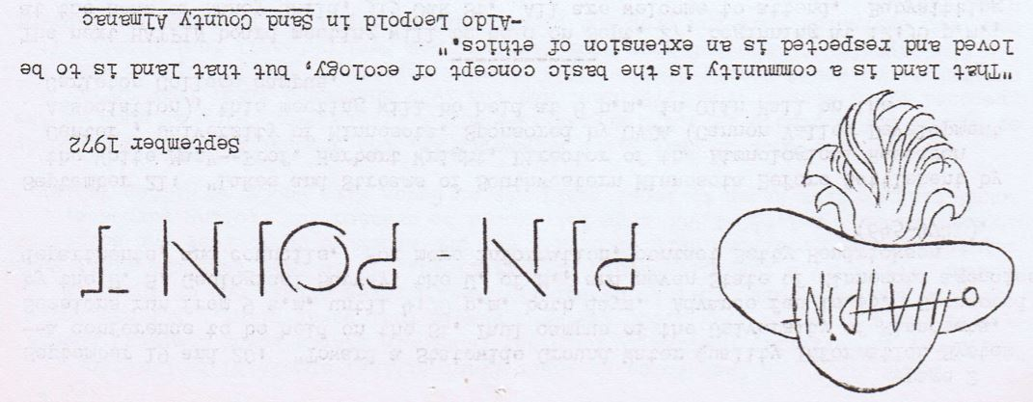

Figure 1: Opening header of the September 1972 issue of PIN-POINT

Not only did they inform the public on relevant environmental issues occurring in Northfield and throughout the nation, they organized community events to combat these issues. For example, in 1971, HATPIN spent much of their year advocating for the protection of the area now known as the Sibley Marsh. In the early 1970s, Harold Ramsey, the owner of the land, wanted to install piping into his marshy property to make it more desirable for housing developers.[10] After hearing this news, HATPIN and other community members set out to prevent this development. Specifically, they wanted to protect the land so that it could be used as an outdoor classroom for the adjacent property, Sibley School. They did this by purchasing the marsh. HATPIN raised the initial funds for purchase, however, they turned these funds over to the Northfield Community Memorial Foundation (NCMF). The NCMF then used those funds, as well as their own, to purchase the land from Ramsey. After this, the foundation gave the land deed to Sibley School.[11] In addition to aiding the purchase of the land, HATPIN helped create a binding agreement to secure the marsh as a *permanent* educational site for Sibley School.

HATPIN also donated to a wide array of local environmental causes. In 1973-74, HATPIN donated $120 to help pay for trucks to haul recycling away from curbs. In 1980, they donated money for prairie seed purchase for Sibley School. In 1997, they donated money to the Cannon River Watershed Partnership. These are just a few examples of their donation history.[12]

***Legacy***

HATPIN was involved with countless environmentalist initiatives in Northfield. They were also indirectly correlated with environmental activism in other cities.

For example, HATPIN inspired Martha Gerdt to combat pollution in her city. Here is a transcription of a letter written to Lynn Carlin from Martha Gerdt.

“Dear Mrs. Carlin,

After reading in the Minneapolis paper on what you housewives have done in Northfield to fight pollution, I decided I would see what I could do to get the women of Wasea also working against pollution. I have felt that something should be done for some time and it doesn’t look as if our government is going to get active about it soon enough. We desperately need action now…

I brought up the project at my Catholic Daughters meeting last nite and it was decided we would have a committee to see what we could do to get some action going. Could you give me any tips on what you have done and how. We already have a little collection by the 4-H, and the scouts are working on a project for packing up the tin cans and newspapers.

I was originally a Northfield girl...and am glad to see my home town leading the action.

Any help you can give us will be appreciated.

Sincerely,

Martha Gerdt[13]

Clearly, HATPINs impact reached beyond Northfield’s borders.

HATPINs efforts did not go ignored. In 1976, the Environmental Protection Agency (EPA) presented HATPIN with an award. According to a newspaper article that described the decoration ceremony, HATPINs award was bestowed due to the group’s “efforts to establish three natural area open to students and the pubic, providing places to study prairie, marsh, and forest ecology.”[14]

The group disbanded in 2002[15] due to the lack of stay-at-home wives in the community.[16] Though the group no longer exists, its legacy of environmental activism remains.

***Additional Research***

To improve this narrative, future researchers should expand on HATPIN’s presence in the community, describing more instances of their involvement in Northfield. More information could likely be found in the Northfield News.

Citations

Gottlieb, Robert, “Reconstructing Environmentalism: Complex Movements, Diverse Roots in *American Environmental History*, ed. Louis Warren (Malden: Blackwell Publishing, 2003), 254.

May, Maggie. Northfield News. “Maggie recalls continued importance of HATPIN to all of us.”April 9, 2003. Retrieved from <http://www.southernminn.com/northfield_news/archives/article_492038d5-e077-5324-840c-f7d23fa79c2e.html>

Northfield Historical Society. HATPIN Archives. File 5: Acquisition of Sibley Marsh Land - info and articles, surveying and development. Northfield News Article, *City Considers Developments* (11/20/70).

Northfield Historical Society. HATPIN Archives. File Name: Articles of Incorporation. HATPIN INC.

Northfield Historical Society. HATPIN Archives. File Name: HATPIN - Correspondence. Letter from Martha Gerdt to Lynn Carlin.

Northfield Historical Society. HATPIN Archives. File Name: HATPIN Flyers. Ecology in the Kitchen and Making a Compost Heap.

Northfield Historical Society. HATPIN Archives. File Name: HATPIN History – 1981 Summary of 1st 10 years.

Northfield Historical Society. HATPIN Archives. File Name: Inventory of materials donated to the NHS 1995.07.02. Handwritten notes likely written by Mary Dyer-Bennet.

Northfield Historical Society. HATPIN Archives. File Name: HATPIN Newsletters, lists and related materials. Notes of Mary Dyer-Bennet, dedicating benches in honor of the late Lynn Carlin. (n.d.)

Northfield Historical Society. HATPIN Archives. File Name: HATPIN Xeroxed clippings, etc. HATPIN Contributions to schools, nature areas, trails, etc.

Northfield Historical Society. HATPIN Archives. File Names: HATPIN Flyers. Ecology in the Kitchen and Making a Compost Heap.

Northfield Historical Society. HATPIN Archives. File Name: PINPOINT 1971-1973. (March 1973).

Northfield Historical Society. HATPIN Archives. File Name: United States Environmental Protection Agency.

Warren, Louis S. *American Environmental History*. Malden, MA: Blackwell Pub., 2003.

1. Northfield Historical Society. HATPIN Archives. File Name: HATPIN Newsletters, lists and related materials. Notes of Mary Dyer-Bennet, dedicating benches in honor of the late Lynn Carlin. (n.d.)
2. May, Maggie. Northfield News. “Maggie recalls continued importance of HATPIN to all of us.”

   April 9, 2003. Retrieved from <http://www.southernminn.com/northfield_news/archives/article_492038d5-e077-5324-840c-f7d23fa79c2e.html>
3. Northfield Historical Society. HATPIN Archives. File Name: HATPIN Newsletters, lists and related materials. Notes of Mary Dyer-Bennet, dedicating benches in honor of the late Lynn Carlin. (n.d.)
4. Warren, Louis S. *American Environmental History*. Malden, MA: Blackwell Pub., 2003.
5. Gottlieb, Robert, “Reconstructing Environmentalism: Complex Movements, Diverse Roots in *American Environmental History*, ed. Louis Warren (Malden: Blackwell Publishing, 2003), 254.
6. Northfield Historical Society. HATPIN Archives. File Names: Articles of Incorporation. HATPIN Inc.
7. Northfield Historical Society. HATPIN Archives. File Name: HATPIN History – 1981 Summary of 1st 10 years.
8. Northfield Historical Society. HATPIN Archives. File Name: PINPOINT 1971-1973. (March 1973).
9. Northfield Historical Society. HATPIN Archives. File Names: HATPIN Flyers. Ecology in the Kitchen and Making a Compost Heap.
10. Northfield Historical Society. HATPIN Archives. File 5: Acquisition of Sibley Marsh Land - info and articles, surveying and development. Northfield News Article, *City Considers Developments* (11/20/70).
11. Northfield Historical Society. HATPIN Archives. File 8: HATPIN - Xeroxed clippings, etc. Sibley Marsh and Prairie Guidebook. (n.d).
12. Northfield Historical Society. HATPIN Archives. File Name: HATPIN Xeroxed clippings, etc. HATPIN Contributions to schools, nature areas, trails, etc.
13. Northfield Historical Society. HATPIN Archives. File Name: HATPIN - Correspondence. Letter from Martha Gerdt to Lynn Carlin.
14. Northfield Historical Society. HATPIN Archives. File Name: United States Environmental Protection Agency.
15. Northfield Historical Society. HATPIN Archives. File Name: HATPIN Xeroxed clippings, etc. HATPIN Contributions to schools, nature areas, trails, etc.
16. Northfield Historical Society. HATPIN Archives. File Name: Inventory of materials donated to the NHS 1995.07.02. Handwritten notes likely written by Mary Dyer-Bennet.