Alejandro G., Hannah M., Molly R., Sarah O

Northfield Area Community Solar White Paper

Environmental Ethics

3.11.16

Kim Smith

Evaluating the Ethics of Carleton College Investing in Community Solar

**Introduction**

Carleton College recently committed to being the primary investor in a local community solar array through Northfield Area Community Solar. This project is small compared to Carleton’s total energy consumption of about 16,000megaWatt/hours per year, but will be symbolic of Carleton’s commitment to sustainability. Its location will provide good publicity to prospective students since the array will be built near the Kracum wind turbine at the southeast corner of the campus. However, this is not the only project on the table: Mary Jo, a representative of Northfield Area Community Solar, is hoping that Carleton will be the primary investor in a 5 megaWatt array. This project is ten times larger than the one Carleton has committed to, and would create about as much energy as one of Carleton’s wind turbines. Both solar projects would provide a slight net financial gain for Carleton, and would help “keep the community in community solar” by partnering with the local Northfield Area Community Solar (Cristofaro). Although on first glance these projects *seem* to align perfectly with Carleton’s goal of carbon neutrality by 2050, the reality is that the energy from these community solar projects *cannot* be counted towards Carleton’s carbon neutrality goals. Is it ethical for Carleton to invest in the large community solar project when the energy produced cannot count towards Carleton’s carbon neutrality goals?

Community solar allows subscribers to receive 25 years of credit on their energy bill for solar energy production (as an effective and environmentally-friendly alternative to fossil fuel energy production) without having to install panels on their own property (See Appendix). Community solar has taken off in Minnesota since 2013 when legislation changed to require Xcel to buy energy produced by community solar installations. Mary Jo described the subsequent boom as a “solarcoaster”, and David Wakely of MN Community Solar said: “We are seeing people all around the state, all walks of life, all political persuasions all piling on because they want energy independence, they want to reduce the amount of pollution that they generate, they want to see their electricity generated closer to home.” Carleton is entering this solar boom by committing to investing in 40% of a 500kW project with Northfield Area Community Solar. Currently, the project is waiting for Xcel’s approval; in fact, Xcel has been stalling so much in its approval of solar projects that locals participated in a “Slow Walk” to protest. In a comical demonstration, protesters dressed up as Xcel representatives and mockingly acted out representatives falling asleep on solar project applications; they proclaimed that “we have to create a new culture that doesn’t say you can take whatever you want from the Earth and pollute it at the same time” (Cristofaro, 12 Feb 2016).

Once Xcel approves the solar projects, Carleton will decide whether to pay the developer up front or pay over time. In either situation, the developer would buy the panels, Xcel would purchase the energy from the panels, and Xcel would credit the subscribers. This is profitable for the developer because they benefit from a 30% tax credit on the panels and the depreciation of the panels over time. The 500kW array would cost $1,149,078 up front, and would pay back in about 19 years, with a net $483,339 profit after 25 years. If Carleton pays the developer over time, they will never lose money, but will only have a net gain of $158,233. The net gain in each situation is small compared to the $1,000,000 Carleton spends on energy each year. Therefore, these solar projects slightly help Carleton from a financial standpoint.

Carleton is not allowed to count the energy from the community solar panels towards its carbon neutrality goals due to the fact that Xcel purchases the energy from the developer. Since this energy goes onto the grid, it counts towards Xcel’s renewable energy goals of reducing their 2005 carbon emission by 30% by 2020. Thus, if Carleton counted the community solar energy towards its own carbon neutrality goals, Carleton would be double counting the renewable energy credits. Even so, Carleton’s investment in community solar fulfills part of Carleton’s duty as a mission-based non-profit corporation and contributes to the creation of renewable energy. **It is ethical for Carleton to invest in community solar: this paper will explore how three widely-accepted ethical frameworks -- those of Milton Friedman, Edward Freeman, and Jessica Fahlquist -- support the claim that Carleton should invest in community solar.**

**Ethics of Milton Friedman**

In the United States today, corporations hold significant power for facilitating social change. Corporations generally have greater access to human and financial resources for service projects that are beneficial to humanity than individuals do. There is substantial debate over whether or not corporations should invest time and money in the pursuit of social causes.

Milton Friedman, a highly influential American economist, maintains that businesses cannot be said to have social responsibility. He argues that corporate executives only have a direct responsibility to conduct the business in accordance with the desires of their employers (the owners of the business). In order for a corporate executive to have a “social responsibility”, he or she would be spending someone else’s money for a general social interest, which is no different from imposing taxes *and* deciding how the tax money will be spent (Friedman). This reduces the amount of money and time that customers and employees have to spend on social interests that they each find valuable. Aneel Karnani, professor at the Ross school of business at University of Michigan, also argues against corporate social responsibility; she believes that if some socially desirable activity is profitable, then corporate social responsibility is simply irrelevant. Therefore, a socially desirable activity would be ineffective where private profits and public welfare are in conflict (Karnani). Karnani sees many flaws in the pursuit of corporate social responsibility, and denounces the idea as theoretically thin, politically naive, ahistorical, and empirically weak.

By this line of ethical and economic thought, corporations only have a responsibility to comply with its established purpose. Friedman sees the objective of corporations established for a charitable purpose as the rendering of certain services, without regard to monetary profit. By Friedman’s views, a school, as a corporation with an eleemosynary (charitable) purpose, only has responsibilities to strive to satisfy its mission statement. Thus, Carleton College’s sole responsibility is to adhere to the goals set out by its mission statement. Several interpretations of Carleton’s mission statement align with the school investing in a community solar garden.

**The Mission Statement**

***Education***

Carleton College is justified in investing in community solar energy since financial, educational, environmental, ethical, and humanitarian behavior align with Carleton’s mission statement. On the grounds of its primary mission “to provide an exceptional undergraduate liberal arts education”, Carleton is wise to invest in alternative energy sources as oil prices rise and as the fossil fuel market becomes increasingly unstable (Rogers). Carleton will be able to focus more on the educational needs of its students if it faces less financial uncertainty due to fossil fuel scarcity.

***Service to Humanity***

The mission also states that Carleton aspires “to prepare students for lives of learning that are [...] of service to humanity.” Research has found that the position of schools as role models for their students should not to be underestimated. By displaying humanitarian values, the school would facilitate the “cultural transmission of accepted values, and the inculcation of habits through authority and discipline,” as well as facilitate “methods that foster understanding of moral principles and cognitive growth” in its students (“About Campus” 308). Carleton needs to set an example in order to produce graduates who have the inclination to serve humanity. Northfield Area Community Solar serves humanity in several ways: it prevents negative environmental consequences associated with fossil fuel use, and it provides more accessible renewable energy for people who do not have the resources to install their own solar panels (Schaffer). Carleton’s commitment to Northfield Area Community Solar will set an example of humanitarian behavior for its students.

***Ethical Action***

Carleton’s mission statement also claims to work to protect its values “within a culture of […] ethical action”. Ethical action calls for the protection of the natural environment, according with a line of ethical theory which advocates for duties to future generations.

Martin Golding, a professor of philosophy, and law at Duke University, includes caring for the environment in our ethical duty to future generations. Golding, explores the question of whether our moral community includes future generations, and how to determine what we are obliged to do in relation to their welfare. Our ethical duties to others are determined based on a *social ideal,* a “conception of the good life for man” (Golding 286). Golding maintains that, “Future generation are members of our moral community because... our social ideal is relevant to them, given what they are and their conditions of life” (287). In other words, our moral community extends as far as our social ideal applies. Since our conception of the good life includes cooperation with other members of society, we enter into a social contract with other people who share our social ideal. Our “altruistic impulses and fellow-feeling” extend this social contract to include future generations (Golding 286); however, this poses a complicated question: “Is our conception (...) of the good life for man relevant to future generations?” (288). Golding concludes that since we cannot be sure of what will constitute a good life in the future, the best we can do is to remove the obstacles that stand in the way of future generations realizing a good life (288). This, according to Golding, “involves not only the active task of cleaning up the environment and making our cities more habitable, but also implies restraints upon us” (288). These “restraints” are easily interpreted to include an obligation to control pollution and conserve the Earth’s resources. Therefore, by Golding’s thoughtful and conservative analysis[1], our ethical duties to our moral community include limited obligations to future generations which therefore entail obligations to protect the environment.

Carleton’s interest in sustaining a culture of ethical action, includes a duty towards the environment. Investing in Northfield Area Community Solar is a step in the right direction, since this will limit pollution from fossil fuels and therefore slow the accumulation of greenhouse gases.

***Citizenship***

Carleton also strives to develop “qualities of mind and character that prepare its graduates to become citizens and leaders, capable of finding inventive solutions to local, national, and global challenges”. The notion of citizenship, in a world plagued by environmental issues must include a duty towards the welfare of the environment.

Andrew Dobson, a British political theorist, delves into the concept of *ecological citizenship,* seeing “sustainable society” as a social objective (85). He references the work of Mark Smith, who says: “At the centre of this intellectual project is the firm conviction that conventional conceptions of justice and citizenship do not provide the human species with an adequate set of tools for resolving the difficulties created by ecological damage today” (Smith 1998: 91). Dobson also cites Dinah Shelton who connects existing human rights to life, personal security, health, and food to the need for a safe and healthy environment “as a pre-condition to the exercise of existing rights or as inextricably entwined with the enjoyment of these rights” (Shelton 105). Due to a heightened level of ecological damage caused by modern human society and the importance of environmental health for the fulfillment of basic human rights, our moral codes as citizens must be extended to include duties towards the environment.

In accordance with Dobson’s ethical theory, Carleton's interest in developing graduates into citizens and leaders necessarily implies a duty to conserve natural resources. This duty to help the environment is a moral requirement of citizenship in order to ensure the continued health of natural systems for the sake of current and future generations.

These environmental ethical theories show that the presence of educational goals, ethical goals, and citizenship goals in Carleton's mission statement constitute a duty towards the environment. Investing in a community solar garden is an ethical way to address a relevant environmental issue, provide students with an excellent education, and set an example of humanitarian behavior for students. However, Carleton’s duty to the environment is not only due to its *educational* mission statement, but also to commitments to other organizations.

***The American College & University Presidents' Climate Commitment (ACUPCC)***

Carleton College has committed to being part of ACUPCC, an organization whose mission is to build a “sustainable and positive global future” by creating leadership networks among higher educational institutions. The college is committed, by signature, to following the organization’s mission statement, which is centered on the promotion of higher education leadership in combatting climate change (Second Nature Mission Statement). Carleton’s efforts to maintain its commitment are clear through its established sustainability department and Climate Action Plan. Subscribing to community solar is a good way for the college to contribute to the fulfillment of the goals outlined by ACUPCC, by putting money towards the production of sustainable alternative energy to be used in the place of fossil fuels.

**Ethics of R. Edward Freeman**

As a direct counter to the shareholder theory discussed above, scholars bring up the stakeholder theory. This theory, attributed mainly to R. Edward Freeman, states that corporations have a social responsibility to attend to the welfare and wellbeing of not only their shareholders but also a group called “stakeholders”. This theory provides another framework for why Carleton College’s decision to invest in Northfield Area Community Solar was an ethical decision. Freeman defines stakeholders as “those groups who are vital to the survival and success of the corporation..[or] groups or individuals who can affect or are affected by the corporation” (215). Examples of stakeholders include consumers, suppliers, employees, community members, and the environment. Freeman’s argument, as analyzed by Kevin Gibson, a professor of philosophy at Marquette University, takes the following form to prove that businesses have duties to stakeholders:

“P1. There are groups identifiable as stakeholders.

P2. These groups have interests.

P3. The interests have been protected by legislation[2].

P4. Entities with recognized interests have rights.

P5. Rights-holders have legitimate claims and obligations.

P6. Rights holders are entitled to a degree of equality which results in maximum fairness to all right holders.

Therefore:

C. Businesses have duties to stakeholders” (Gibson 249).

Thus, Carleton College, as a business, has duties to its stakeholders. These stakeholder groups include the management of the college, employees, current students, parents, alumni, donors, and community members.

While this is a logical progression which provides a framework for understanding how duties to stakeholders have been attributed to businesses, it becomes stronger in relation to Carleton College and its stakeholders with the addition of Gibson’s moral basis to the theory. This moral addition provides a system of assessment for corporate social responsibility that clearly outlines who is a stakeholder, and what responsibility a corporation has to stakeholders. Gibson states that “the scope of corporate responsibility is limited to dealing with other moral agents” (252). Thus, we must prove that both stakeholders and corporations are moral agents.

Gibson holds that stakeholders are different from individuals because a group has a “different identity and different characteristics from its members” (251). This is important because duties to individuals are more complicated than duties to groups. In assessing whether a group has moral agency as a stakeholder, he states that one must consider “two conditions…identity and intentionality” (Gibson 251). In other words, can you define the distinct identities and specific values of these stakeholder groups? The stakeholders listed above can be identified as distinct since each group contains a diverse group of individuals that all have attributes in common. While there is some overlap between groups, such as between community members and staff, there are distinct roles that staff members take on at work that are different from their role in the community. Identifying specific values for each group is beyond the scope of this paper, but values relating to environmental issues for some groups will be discussed later in this paper.

Defining the moral status of businesses and stakeholders does not complete our task of understanding how stakeholders and corporations interact. In order for there to be a moral basis for corporate social responsibility there also needs to be way to assess the moral structure of the corporation. To accomplish this, Gibson draws on Peter French’s *Corporate Internal Decision Procedure*: which states that a corporation that has “a mission statement, written policies, and a set form for making decisions which supersede those of any one individual” (Gibson 215). Thus corporations are not solely run by an individual’s moral compass (which is subjective), but as a unit capable of making moral decisions. Furthermore, the corporation is a moral agent when it has “(i) a discernable corporate disposition or ‘culture’, and (ii) continuity which would survive changes in membership” (Gibson 252). Carleton College fulfills all of the requirements placed on corporations. It has a mission statement, policies that guide decisions (one decision that is particularly relevant to this discussion is the 2011 Climate Action Plan that aims for carbon neutrality by 2050), and a board style of management (meaning that decisions are made by groups rather than individuals). As an established private liberal arts college that has been active for over 100 years it is expected to continue serving its role as a college for many more years to come, despite changes in the people who make up the college’s stakeholders. Thus we can expect to see continuity from year to year.

Having established that Carleton College and its stakeholders are moral agents, we return to the specifics of the community solar case. Based on Freeman’s ground rules for a Doctrine of Fair Contracts, we assess the validity of the contract that Carleton College has with Northfield Community Solar to support a 5 kilowatt community solar garden. Freeman’s six ground rules are as follows: 1. The Principle of Entry and Exit, 2. The Principle of Governance, 3. The Principle of Externalities, 4. The Principle of Contracting Costs, 5. The Agency Principle, and 6. The Principle of Limited Immortality (Freeman 219, 220).

The Principle of Entry and Exit says that “any contract with the corporation must have clearly defined entry, exit, and renegotiation conditions” (Freeman 219). Carleton College’s contract with Northfield Area Community solar has exactly this principle, and since the college is a stable institution, it is a safe and ethical contract to enter. Secondly, the Principle of Governance states that “the procedures for changing the rules of the game must be agreed upon by unanimous consent” (Freeman 219). This principle is harder to apply to Carleton College and logistically difficult to execute with such a large and varied group of stakeholders. Furthermore, this principle exists to keep majority stakeholders from overwhelming minority stakeholders; however, if the college acts as a corporation leader, then all stakeholders have equal weight and this principle is nullified.

Thirdly, the Principle of Externalities states that “if a contract between A and B imposes a cost on C, then C has the option to become a party to the contract, and the terms are renegotiated” (Freeman 219). If the contract between Carleton College and Northfield Area Community Solar imposed a cost on other parties, then this principle would need to be enacted to ensure that all stakeholders were treated fairly. However, since the money Carleton is investing in community solar was not slated for a different use, and the college will earn back the entire investment, third party considerations are not relevant. Martha Larson, the manager of campus energy and sustainability at Carleton, explained that the money being invested in the community solar garden is intended only for this use, and thus is not hurting any other stakeholder group. Fourth, the Principle of Contracting Costs states that “all parties to the contract must share in the cost of contracting” (Freeman 219). This is the same principle that the system of a community solar garden relies upon for success. Carleton and other corporations and individuals have each purchased shares in Northfield Area Community Solar’s proposed solar arrays equal to the percentage of the garden they are funding.

Fifth, the Agency Principle states that “any agent must serve the interests of all stakeholders” (Freeman 220). Carleton College, as a moral agent, is bound to this principle. Is supporting solar in the interests of all stakeholders? We do not have sufficient information to make claims about the interests of all stakeholders at Carleton College. However, a recent survey of Carleton students showed that students rank environmental issues high on a list of social issues (Smith). Thus if the college invested in sustainable energy, such as community solar, this would be in line with the interests demonstrated by the student body. The survey found that Carleton students rank protecting the environment third in a list of important political issues, and working to preserve the environment third on a list of personal life goals[3]. These results indicate that the student body is concerned about sustainability and would support policies that move the college in a more sustainable direction. By investing in Northfield Area Community Solar, Carleton College is serving students’ educational interests. The college is committed to providing an “exceptional undergraduate liberal arts education” and it is in each student’s educational interests for the college to commit to community solar because the solar project will help to reduce the college’s dependence on fossil fuels. As stated earlier, in an increasingly volatile fossil fuel market, we can predict that the college will end up paying more for fossil fuels in the future. Investing in community solar will make more monetary resources available for each student’s educational needs. To look at other stakeholders in this interaction, community members are the ones who began the community solar movement for Northfield, so purchasing a share of community solar is also in their interests. Employees and faculty are unaffected by the agreement. Additionally, applying the third principle, since they are not being negatively affected we can assume that supporting community solar has no impact on their interests. Finally, it is certainly in the interests of the environment[4] for Carleton to support community solar as it will reduce the college’s dependence on fossil fuels.

Sixthly, the Principle of Limited Immortality states that “the corporation shall be managed as if it can continue to serve the interests of stakeholders through time” (Freeman 220). Since Carleton is an established institution, there is little risk that it will cease to exist in the foreseeable future. Additionally, investing in the community solar garden will help ensure the health and continuity of stakeholders such as the community and the environment which are valued by Carleton and other stakeholders like students and faculty. Finally, since there is a complete return on the investment after 25 years, this is a responsible investment of Carleton College’s funds.

After assessing the nature of the project and the interests of Carleton’s stakeholders, we have shown that the stakeholder theory provides support for Carleton College’s decision to invest in community solar. This assessment was based on the moral status of the college and its stakeholders and the fulfilment of Freeman’s Doctrine of Fair Contracts.

**Ethics of Jessica N. Fahlquist**

This paper has shown how several schools of thought lead to the same conclusion: it is an ethical decision to invest in community solar. Friedman justifies it through the analysis of the mission statement, and Freeman does so through the Stakeholder Theory. Jessica Fahlquist provides another school of thought that affirms the ethics behind investing in community solar.

Fahlquist argues that if an “individual is in a good position to do something to contribute to the solution of environmental problems, then that individual has a responsibility to do so” (118). She derives this conclusion from a more general moral principle, which asserts that richer nations bear a greater responsibility for the prevention of climate change since rich countries have the “resources to solve these problems” (Fahlquist 117). Fahlquist’s “forward-looking” argument does not derive from the fact that nations have, “historically, contributed more to the emissions of carbon dioxide,” but rather from the fact that richer nations have more resources to actually enact change. Colleges, though neither as small as an individual nor as grand as a nation, have a similar responsibility; they possess “institutional responsibility.” Carleton, as a fairly large institution, has the “power to create opportunities for individuals to do what is right” (Fahlquist 119). The responsibility of institutions is twofold. They have, on one hand, the ability to expose resources to individuals. On the other hand, institutions have the resources to enact change themselves.

Fahlquist notes that “the virtue of behaving responsibly is affected by socials systems, policies, information and education (120),” and proceeds to note that institutions have the ability to influence social systems, policies, and information and education. This means that educational institutions have the ability to influence how virtuous individuals can be, especially in terms of the information and education students receive.

By being a role model, colleges can influence the information and education students receive. It is important to focus on messages the college conveys, since they influence the campus culture, and campus culture influences the ethical thinking of the students. If a college refrained from participating in any environmental action, how would that affect campus culture? Students would receive the underlying sense that environmental action cannot coexist with the college’s mission. However, an institution that emphasizes and pursues virtuous sustainable practices would convey to its students the importance of environmental stewardship, as well as the achievability of harmonizing self-interest and environmental interest.

Virtuous institutional practices and policies not only send virtuous messages to students, but also bring issues to the campus, and allow students to interact in social and academic settings with the subject that a given policy or practice involves. The associate professor at the Department of Psychology in Notre Dame, Jay W. Brandenberger, explains in his essay “College, character and social responsibility” that ethical “intelligence is based on activity, on interacting with the environment to learn” (“About Campus” 309). Carleton College needs to create the environment in which students can interact, and it can do so by making issues, such as sustainable energy, more relevant on campus. Investing in community solar makes the issue of solar energy, and the ethics behind the investment, much more relevant to the campus.

Community solar is an example of an issue that allows students to grapple and interact with an ethical issue. Martha Larson, Manager of Campus Energy and Sustainability, explained that investing in community solar can lead to raising awareness of the evolving technologies that help protect the environment. She also explained that the garden could be part of the tours of the college, which would directly inform prospective students, current students, and even faculty of environmental issues. Community solar becomes an opportunity that allows students to engage in ethical discussions about the environment thereby making individuals more “virtuous.”

Using Fahlquist’s argument, Carleton can fulfill its duty to the environment, its mission, its students, and the Northfield community by being a role model for sustainable practices through the subscription to community solar.

**Conclusion:**

Friedman, Freeman, and Fahlquist’s ethical theories of business each independently support the same conclusion: Carleton has an ethical responsibility to invest in community solar. In addition to this sound consensus, Carleton students also support the school’s involvement in community solar. A recent survey showed that 83% of a random stratified sample of Carleton students support the construction of the larger, 5 megaWatt array (See Appendix)[5]. Therefore, Carleton should invest in both the .5 megaWatt array and the 5 megaWatt array in order to adhere to its Mission Statement, fulfill its duty of social responsibility, act as a role model, and make the energy grid more sustainable.

**Appendix 1:**

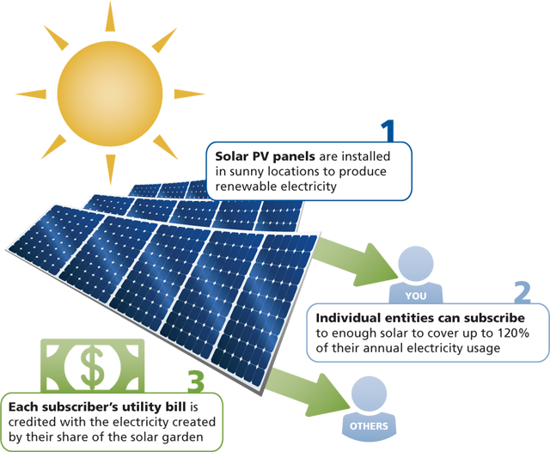

Source: CERTs

**Appendix 2:**

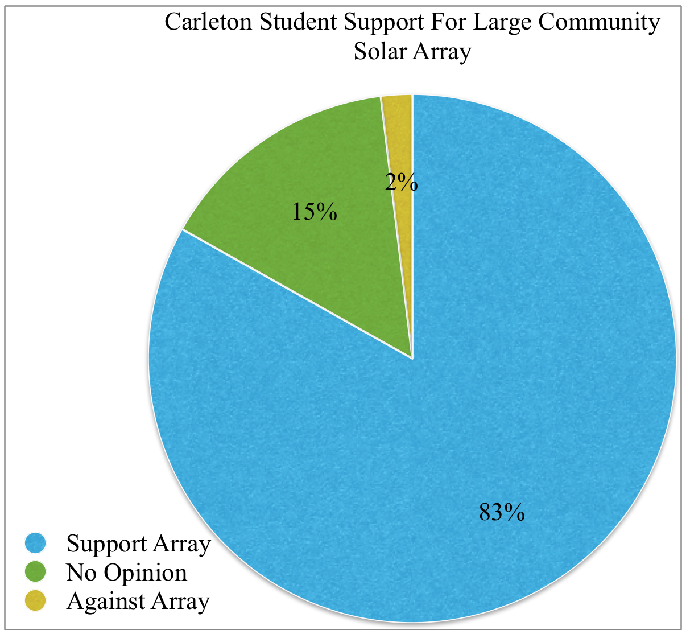

**Bibliography:**

Berkowitz, Marvin, and Michael Fekula. "About Campus." Educating For Character (1997): 17-22. Web.

Carleton Climate Action Plan Steering Committee. "Climate Action Plan." *Carleton College*. Carleton, May 2011. Web. <<https://apps.carleton.edu/sustainability/assets/11.06.13_CarletonClimateActionPlan.pdf>>

Carleton. "About Carleton." *: Our Mission*. Carleton, n.d. Web. 12 Feb. 2016. <https://apps.carleton.edu/about/mission/>.

Carr, David. "Moral Values and the Arts in Environmental Education: Towards an Ethics of Aesthetic Appreciation." *Journal of Philosophy of Education* 38.2 (2004): 221-239.

Cristofaro, Mary Jo. Personal Communication. 28 Feb 2016

Cristofaro, Mary Jo. "Community Power Final." *YouTube*. YouTube, n.d. Web. 12 Feb. 2016. <https://www.youtube.com/watch?v=iazBIA4VaVM>.

Dobson, Andrew. "Ecological Citizenship." Citizenship and the Environment 27 Nov. 2003: 83-141.

Fahlquist, Jessica N. "Moral Responsibility for Environmental Problems--Individual or Institutional." (2009): n. pag. Web.

Freeman, R. Edward. “A Stakeholder Theory of the Modern Corporation.” Business Ethics: People, Profits, and the Planet. Ed. Kevin Gibson. New York: McGraw-Hill, 2006. 212-221. Print.

Friedman, Milton. "The Social Responsibility of Business is to Increase its Profits." New  
York Times Magazine. 13 Sept. 1970. Print.

Gibson, Kevin. “The Moral Basis of Stakeholder Theory.” Journal of Business Ethics 26.3 (2000): 245-257. Print.

Karnani, Aneel. "CSR Stuck in a Logical Trap: A Response to Pietra Rivoli and Sandra Waddock's “‘First They Ignore You…’: The Time-Context Dynamic and Corporate Responsibility”." California Management Review 53.2 (2011): 105-111.

Larson, Martha. “Carleton College and Community Solar.” Personal interview. 22 Jan. 2016

"Mission." Second Nature. N.p., n.d. Web. 3 Feb. 2016. <<http://secondnature.org/who-we-are/mission/>>.

MN Dept. of Commerce, Division of Energy Resources, Th. "Minnesota 2013 DG Legislation Summary." *Minnesota 2013 DG Legislation Summary* (n.d.): n. pag. *Clean Energy Resource Team*. MN Dept. of Commerce, Division of Energy Resources. Web. 12 Feb. 2016. <http://www.cleanenergyresourceteams.org/sites/default/files/MN_2013_DG_Legislation_Summary.pdf>.

Phillips, Ari. "How Solar Power Is Learning To Share: The Rapid Growth Of Community Solar Gardens." ThinkProgress RSS. Climate Progress, 09 July 2015. Web. 12 Feb. 2016.

Rogers, Fred. Personal interview. 22 Jan. 2016.

Shaffer, David. “Xcel Opens Door for Community Solar Gardens.” *Star Tribune.* Star Tribune, 19 Dec. 2104 Web. 12 Feb. 2016.

Schneider, Carol Geary, and Richard H. Hersh. "Fostering Personal and Social Responsibility on College and University Campuses." *Association of American Colleges & Universities*. Educating for Personal and Social Responsibility, 02 Sept. 2005. Web. 12 Feb. 2016.

Smith, Kim. “ What Issue Do You Care About 2016 .” Survey. SurveyMonkey. SurveyMonkey,   
8 Feb. 2016. Web. 19 Feb 2016

University of Minnesota. "Corporate Social Responsibility – Institute on the Environment." *Institute on the Environment*. University of Minnesota, n.d. Web. 12 Feb. 2016. <<http://environment.umn.edu/tag/corporate-social-responsibility/>>.

Waddock's “‘First They Ignore You…’: The Time-Context Dynamic and Corporate Responsibility”." California Management Review 53.2 (2011): 105-111.

2014 Carbon Worksheet. "Xcel Energy." X*cel Energy*. Xcel Energy, n.d. Web. 12 Feb. 2016. <http://xcelenergy.com/>.

1. Golding considers, for example, a much less conservative claim that we have an obligation to control our genetic inheritance for the sake of the welfare of future generations (288). Although this is an extreme example, calls are often heard from environmentalists to control human population expansion, which Golding rejects as an ethical obligation.
2. Here Gibson is referencing sections of Freeman’s paper that detail how lawsuits, the Clean Air Act, the Clean Water Act and other federal actions have constrained corporation freedom and protected the needs and rights of outside groups, which are the stakeholders.
3. The survey was an online survey created by Carleton professor Kim Smith’s Environmental Ethics class, and given to a stratified random sample of the Carleton College student body. 200 students per class were asked to take the survey giving a total pool of 800 possible respondents. 262 students completed the survey, giving a response rate of 32%. Since this is a relatively low response rate, it is possible that some bias may exist in the survey results. The two questions referenced are listed here. Q2. We would like to know your opinion on which issues the country should focus on. Using a scale from 1-6 where 1 is the most important and 6 is the least important, rank in order of importance the following six issues the country will be facing over the next few years: improving the economy, cutting government spending, improving public education, protecting the environment, improving the health care system, and reducing gun violence. Q3. Using a scale from 1-7, where 1 is the most important, please indicate how important the following general life goals are to you personally: Becoming an authority in my field, raising a family, being very well off financially, engaging in politics, working to preserve the environment, becoming a community leader, and expanding cultural awareness.
4. 2.The environment as a stakeholder is necessary for an environmental ethic. It is supported by Gibson using the theory of corporations as a moral agent. He states that “one benefit … of treating corporate groups as moral agents in and of themselves is that it would allow them to take on a stewardship or advocacy role for non-agents” (Gibson 254). Thus corporations as moral agents can speak for the trees.
5. Carleton students were asked: “Carleton has plans to purchase a share in a local solar array that would produce the equivalent of 3.5-6% of Carleton’s annual energy consumption for the next 25 years. There is the possibility that Carleton could invest in another solar array that would provide ten times that amount of energy. Would you approve of Carleton using college resources to buy a share in the larger array?” They could answer “Yes”, “No opinion”, or “No”. 217 students answered “Yes”, 39 had “No opinion”, and 5 answered “No”.