

Action Sheet, December 2014

CCL Monthly Conference Call, Saturday, Dec. 6, 2014
Groups meet at 9:45am PT/12:45pm ET
The international conference call starts at 10:00 am PT/1:00 pm ET
The conference call part of the meeting is a little over an hour long and the groups meet for another hour after that to take and plan actions.
Call-in number: 1-866-642-1665, passcode: 440699#
Callers outside U.S. and Canada, please use Skype: 719-387-8317, passcode 440699#

Conference Call Guest:

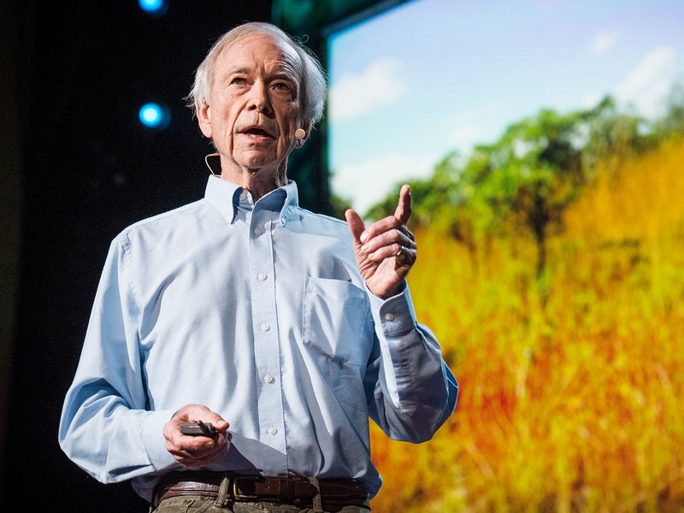
Allan Savory of the Savory Institute
Can we reverse desertification and sequester carbon through cattle herding? That’s the hopeful theory behind the work of our December guest, Allan Savory of the Savory Institute, who began developing his holistic management methodology in Zimbabwe in the 1980s.

Actions

- Generate letters to the editor and op-eds to provide support for Carbon Fee & Dividend as we head into the new Congress.
- Write letters to members of Congress recently elected/re-elected, congratulating them and asking them to support Carbon Fee & Dividend.

LASER TALK
It’s a ‘fee’ not a ‘tax;’ just ask George Shultz

Whenever we talk about placing a fee on carbon to reduce greenhouse gas emissions, the question eventually comes up: Isn’t a “fee” the same as a “tax”?

No, it isn’t. Just ask George Shultz, who was Ronald Reagan’s Secretary of State and also served as Treasury Secretary.

Shultz, who’s an Advisory Board member for Citizens' Climate Lobby, has told CCL, “It's not a tax if the government doesn't keep the money.”

And that’s the point. If all the revenue is given back to the people as direct payments, as Shultz recommends, then they’re not being taxed. The fee is not spent on more government programs. It’s used as a price signal to help the free market gravitate toward clean energy and greater efficiency.

Shultz and his Hoover Institution colleague Gary Becker (who passed away earlier this year) say that by giving the money back directly to people, we create a policy that is simple, transparent and – most importantly – politically viable.

So, let’s call it “The Shultz-Becker Plan: Carbon Fee and Dividend.”

ACTION
Generate letters to the editor and op-eds
As we head into the new year with a new Congress, getting our message about a revenue-neutral carbon fee published in local newspapers will build support and momentum to push legislation forward. This month, we’d like to focus attention on getting letters to the editor and op-eds published. We especially want to encourage members who have not been published to submit letters.
For letters to the editor:
Designate someone in your group to monitor the newspaper for letter-to-editor opportunities that arise and pass those opportunities on to the rest of the group. To kick start this action, bring copies of your local newspaper from the previous three days to your meeting and together look for LTE opportunities. If you find any, start drafting LTEs at your meeting.
Basic LTE outline:
- Open with a reference to the article, column or editorial you are responding to.
- Transition to how this relates to the problem of global warming/climate change.
- Suggest a solution to the problem – pricing carbon, carbon fee and dividend.
- Urge your representative or senator by name to support this solution.
- Close out by circling back to the article you mentioned at the beginning.

For op-eds:
Designate someone in your group who will draft and submit an op-ed to your local paper. Some suggested themes:
- In this season of giving, perhaps the best gift we can offer is a livable world for future generations. Make this very personal: Who are you giving this gift to? What makes this such an important/special gift?
- It wouldn’t be New Year’s without resolutions. Can we resolve to ask that our newly-elected Congress finally work together to solve the greatest challenge our civilization has ever faced?
- No more excuses! Whenever the subject of carbon pricing comes up, critics say “What about China?” and “It will kill jobs.” Well, China has agreed to cap emissions, and an economic study from REMI shows that a carbon fee, rebated back to households, will add millions of jobs. So, what are we waiting for? (See recent media packet post)
If you log into CCL Community, you can watch the CCL-University webinar on publishing op-eds. Our CCL-U on Dec. 11 will also be about drafting and submitting op-eds.

ACTION
Write to congratulate new/old members of Congress
Now that the elections are over, this is the perfect time to write letters to members of Congress – whether they’ve just been elected or they’ve been re-elected – and congratulate them on their victory and wish them well in the new Congress. In addition to the congratulations, though, ask them to support Carbon Fee and Dividend legislation in 2015.

Suggested outline for letter:
- Congratulate your member of Congress for their victory in the November election, and express your hope that they and their colleagues will work together to solve the problems facing our nation.
- Tell them a little about yourself and why the issue of climate change is important to you.
- Ask them to support legislation that places a steadily-rising fee on carbon with revenue given back to households.
- You might also ask them to look at the study from Regional Economic Models, Inc. (REMI), which shows such a solution will create millions of jobs in the coming decades while saving tens of thousands of lives.
- Ask for a reply.
Send your letters to local district offices. Addresses can be found on Web sites of members of Congress, which can be found on www.house.gov and www.senate.gov.
Newly-elected members may not have official Web sites yet, but letters can be sent to their Washington offices at the following addresses:

Rep. NAME HERE
U.S. House of Representatives
Washington, DC 20515

Sen. NAME HERE
U.S. Senate
Washington, DC 20510

